**CIRCUIT DIAGRAM (CLAMPER)**

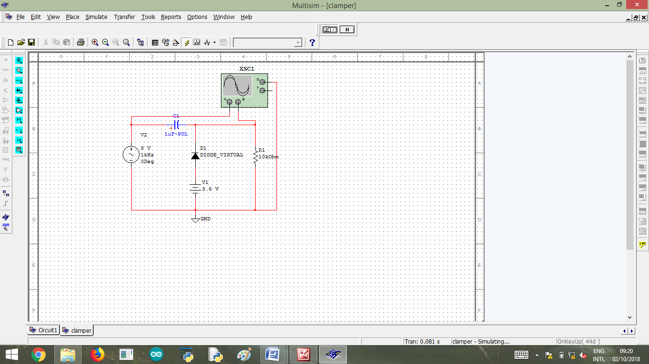

Fig 1: Clamper using multisim

**NET LIST**

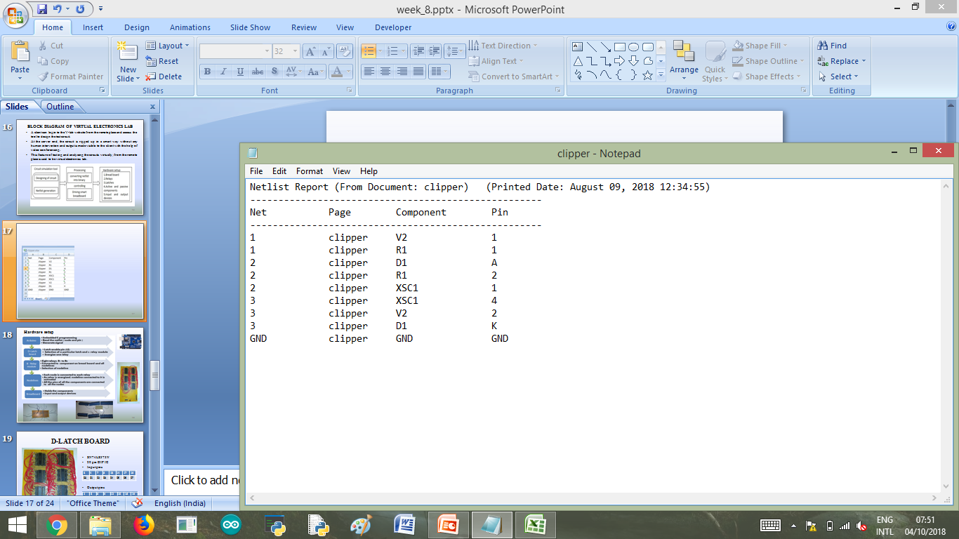

Fig 2: Net list(Clamper)

**RELAY INTERFACING**

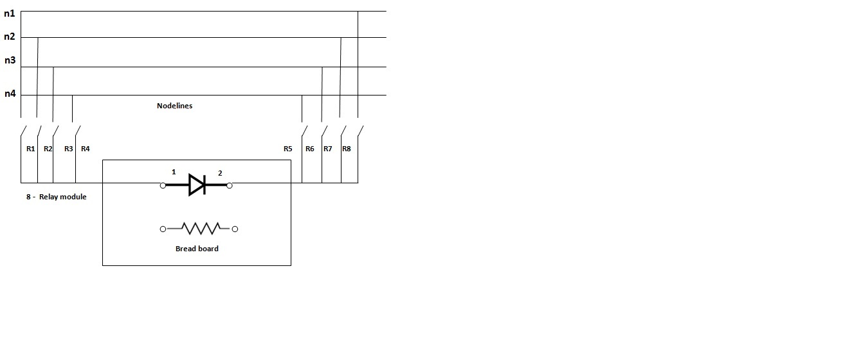

Fig 3: Interfacing relay with node lines and pins

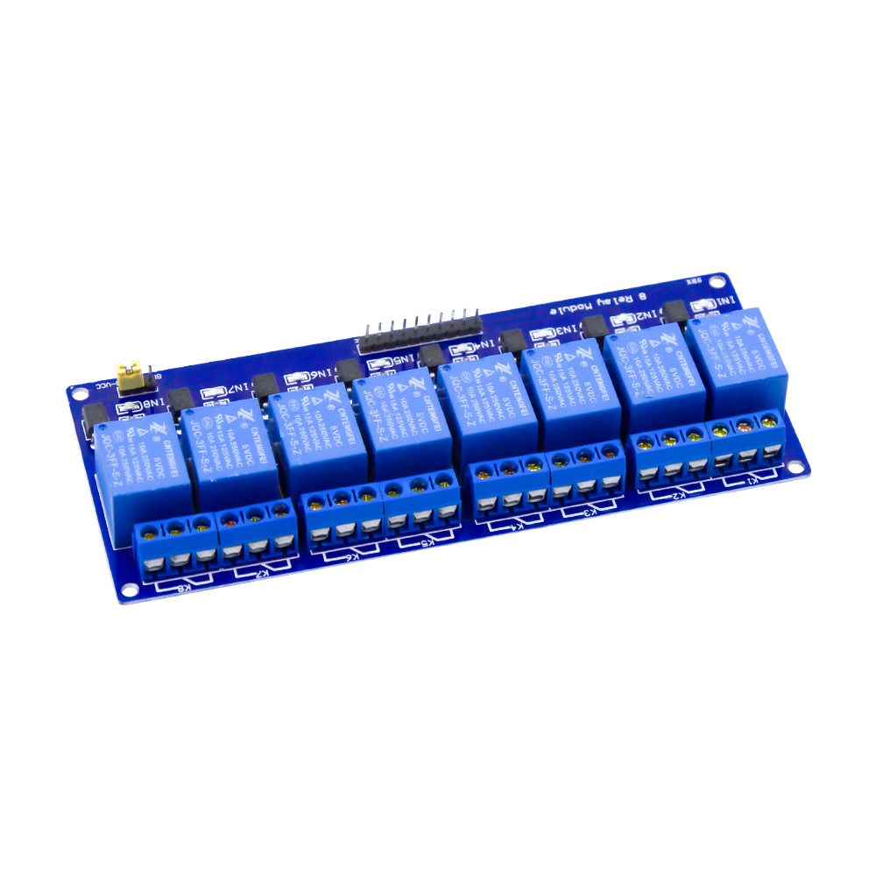

**CONTROL SIGNALS**



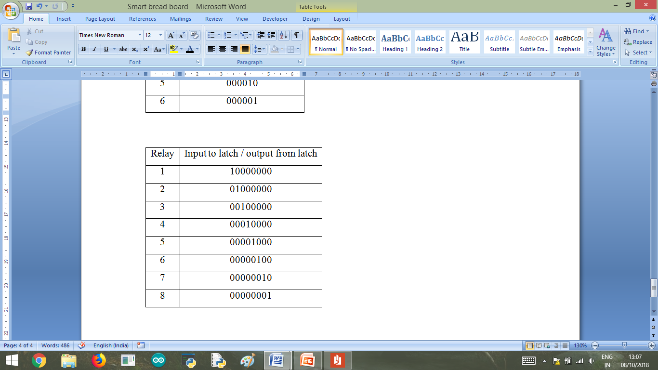

**INTERFACING RELAY WITH RASPBERRY PI 3**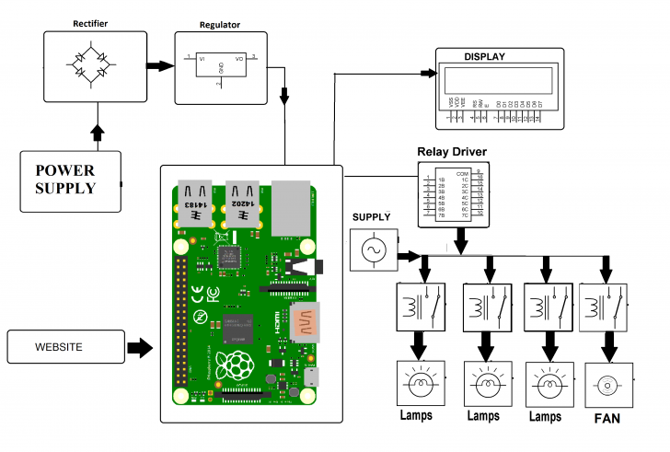

**RELAY DRIVER IC(Drives high power loads)**

